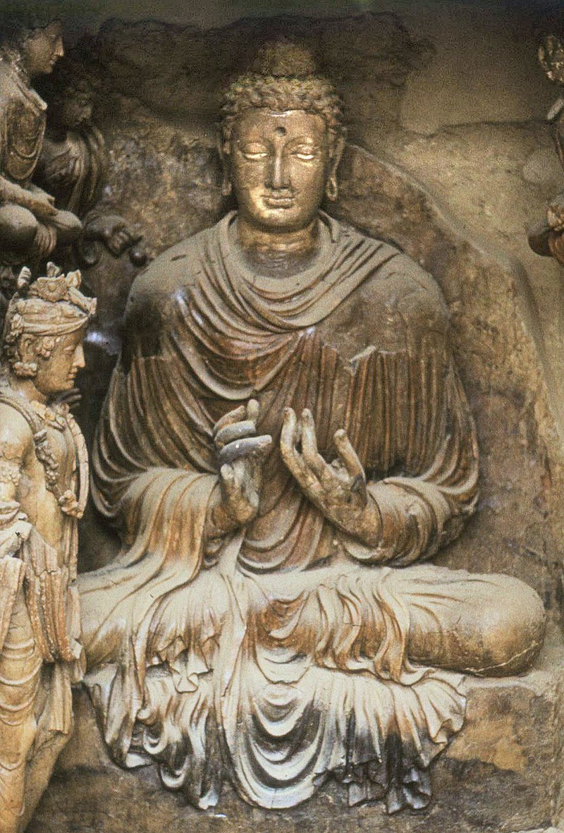**Section: 3- Ascetic Siddhartha (Age 29-35)**

In this section we will focus on how the young prince Siddhartha at the age of 29, left home life in search of the Truth, meeting kings and teachers on his way and undertaking extreme ascetic practices. Finally, to realize the folly of useless practice and decided to find his own path to Awakening.

**The Buddha**, [Tapa Shotor](https://en.wikipedia.org/wiki/Tapa_Shotor) monastery in [Hadda](https://en.wikipedia.org/wiki/Hadda,_Afghanistan" \o "Hadda, Afghanistan), Afghanistan, 2nd century CE

Author: Marek Gawęck

Picture Courtesy: https://commons.wikimedia.org/

**▲ The Great Renunciation**

According to legends the great renunciation (*maha abhinishkramana* ) of Prince Siddhartha occurred in the year of 595 B.C. on a full moon day of Āsāḷha (Esala- month of April) [[1]](#endnote-1).

The Blessed One’s great renunciation is considered the most important event of his life as the milestone for the Buddhist World! The entire Buddhist world is indebted to the Buddha Gotama, who embarked on such a noble task – he renounced his princely life at a very young age in order to find a solution to the cycle of repeated suffering. The story of the Great Renunciation of Prince Siddhartha sets the example of going forth from lay life to homeless life for all Buddhist monks and nuns in our world. Thus, reflecting of the suffering of *samsāra*, the prince saw that if he took up the homeless life, it would be possible for him to seek what he wanted, the solution to the suffering of endless births and deaths.

Before going to say about the wanderings of Ascetic Siddhartha we would like to present the causes which lead the prince to go forth from his princely life.

▲ **What Inspired Prince Siddhartha to become an ascetic?**

In a few suttas in the scriptures the Buddha has mentioned about his renunciation. Some of them are given below so that we could understand how one who was immensely involved in a princely life decided to give away his belongings and attachments and go away to unknown world of homelessness. In the following sutta the Blessed One, tells the Sangha what it was that inspired him to become a homeless wander.

♦ **Seen the suffering of life**

*“Amid such splendour and a delicate life, it occurred to me: …I too am subject to* ***old age*** *and am not exempt from old age. Such being the case, if I were to feel repelled, humiliated, and disgusted when seeing another who is old, that would not be proper for me.’ When I reflected thus, my intoxication with youth was completely abandoned… I too am subject to* ***illness*** *and am not exempt from illness. Such being the case, if I were to feel repelled, humiliated, and disgusted when seeing another who is ill, that would not be proper for me.’ When I reflected thus, my intoxication with health was completely abandoned… I too am subject to* ***death*** *and am not exempt from death. Such being the case, if I were to feel repelled, humiliated, and disgusted when seeing another who has died, that would not be proper for me.’ When I reflected thus, my intoxication with life was completely abandoned…”.* [[2]](#endnote-2)

**Note:** \* In section 2 elaborate the luxurious life lead by the prince. Thus, Prince Siddhartha, who had well understood the intoxication of youth…health, and … life, was undoubtedly shocked by the pleasures of the sensual world. As mentioned earlier (in section 2), he must have realized that the well-being and happiness obtained through Samadhi is more superior than worldly pleasures. He must have realized that everyone, including himself, is subject to the stages of old age, illness, and death. At that time, according to Indian religious beliefs he may had some idea of rebirth- not one- but many? He may have pondered how to escape from such a deadly trap?

Accordingly, he left home searching a way out from worldly suffering, seeking the Truth -Good (*kiṃkusalānuesī)*

Thus, reflecting on these problems, **old age, sickness and death**, Prince Siddhartha saw the reality of life, that everyone who is born is subject to these. The prince realised that not only himself, but also all the people he loved and in fact all the beings who are born are overwhelmed by the inevitable great sorrow of old age, sickness and death. Moreover, it was believed that this cycle of being born and dying (*samsāra*) was endless. Prince Siddhartha renounced his princely life in order to find a way out of these eternal problems, looking for a blissful state.

\* Later, when he became the Buddha, he said this about his noble search:

*“And what is the noble search? Here someone being himself subject to birth… ageing… sickness… death… having understood the danger…in what subject to birth… ageing… sickness… death …seeks the unborn supreme security from bondage, Nibbāna”[[3]](#endnote-3)*

**♦ Home life is not conducive to practice spirituality**

The following extract from scriptures also confirmed that through understanding that difficulties in worldly life the bodhisattva renounced his home life:

*“Here, Aggivessana, before my enlightenment, while I was still only an unenlightened Bodhisatta, I thought: ‘Household life is crowded and dusty; life gone forth is wide open. It is not easy, while living in a home, to lead the holy life utterly perfect and pure as a polished shell. Suppose I shave off my hair and beard, put on the yellow robe, and go forth from the home life into homelessness” [[4]](#endnote-4)*

♦ **Seeking good – the truth**

In Mahāparinibbana sutta (DN:16), at the time of his passing away, Blessed One said this to Subhadda, the last personal disciple of the him [[5]](#endnote-5).

“I went forth seeking **what is good-**

Twenty-nine years of age I was…

When I went forth to seek the Good.

Now over fifty years have passed

Since the day that I went forth

To roam the realm of wisdom’s law…”

*(Ekūnatiṃso vayasā subhadda,*

*Yaṃ pabbajiṃ kiṃkusalānuesī;*

*Vassāni paññāsa samādhikāni,*

*Yato ahaṃ pabbajito subhadda) [[6]](#endnote-6)*

♦ **Seen the Danger in Sensual Pleasures**

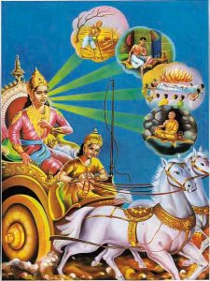In Suttanipatha, there is a passage where the Ascetic Siddhartha saying the purpose of his going forth. When he had an encounter with the King Bimbisara of Magadha in the city of Rajagaha, the king impressed by the good looks and peaceful manners of the bodhisatta, offered him to share his royal pleasure with him. This is what Ascetic Siddhartha said.

*“Up north, O king, on the slopes of the Himalayas,*

*Full of wealth and strength,*

*lies a land of one whose abode is among the Kosalanas.*

*Their clan is named for the Sun they are Sakyans by birth,*

*I have gone forth from that family- I do not yearn for sensual pleasures.*

***Seeing the danger in sensual pleasures****, seeing renunciation as sanctuary,*

*I shall go on to strive that is where my mind delights”. [[7]](#endnote-7)*

**The four sights: source:** [**The Anthropology of Religion**](https://markyjc.wordpress.com/)

Picture courtesy: https://markyjc.wordpress.com/

**Note:** \* According to ancient Buddhist Texts, the prince witnessing the four omen of a recluse and reflecting them determined to abandon his princely life [[8]](#endnote-8).

\* Apart from a statement given in KN:Bv. (given below) we could not find any other place in the scriptures where the four signs, mentioned in traditional Buddhist stories and ancient books: 1) seen an old person 2) seen a sick person 3) seen a dead body 4) seen a peaceful recluse described as causes for Prince Siddhartha to leave his princely life**:**

( mama ekun tisvasak gihigeyi vāsaya keḷemi...satara pera nimiti dæka aśva yānayakin abhiniṣkramanaya keḷemi. mama savasak duṣkaravū pradhan vīriya kelemi) I lived in a house for thirty-one years... I saw four omens and set out on a horse-drawn chariot. I performed a difficult and strenuous exercise for six years. *( Nimithtena chathuro disva assayanena nikhamin – chabbassan padhancharan acari dukkarn ahan)[[9]](#endnote-9)*

\* In Mahāpadāna sutta (DN:14): mentioned tht Buddha Vipaasi seen the four signs left the palace.

▲ **Did the Bodhisatta went away in the middle of night without taking leave from his family?**

In Buddhist literature, the event of his going forth is described in many different ways. Traditional stories about the life of the Buddha often say that Prince Siddhartha left his family without telling them the purpose of his going away. However, in the Suttas we can see a different picture. The Buddha says this to the Sangha:

*‘Why, being myself subject to birth, do I seek what is also subject to birth? Why, being myself subject to ageing, sickness, death, sorrow, and defilement, do I seek what is also subject to ageing, sickness, death, sorrow, and defilement? Suppose that, being myself subject to birth, having understood the danger in what is subject to birth, I seek the unborn supreme security from bondage... later, while still young, a black-haired young man endowed with the blessing of youth, in the prime of life,* ***though my mother and father wished otherwise and wept with tearful faces,*** *I shaved off my hair and beard, put on the yellow robe, and went forth from the home life into homelessness…”* [[10]](#endnote-10)

Although he was young and lived a luxurious princely life, Prince Siddhartha had understood the true nature of existence, that the pleasures of life were very limited and would inevitably be followed by suffering. He may have discussed these things with his beloved Princess Yasodhara, who was also a wise lady and devoted wife. According to Jataka Stories, for countless life-times they had been husband and wife devoted to each other. In those previous lives, when our bodhisattva went forth from the home life, his wife supported him and helped him. So, in the present life also they may have held many discussions about the unsatisfactoriness of lay life and she may have understood the desire of the prince to seek the Truth.

Furthermore, when the Blessed One visited his family in Kapilvatthu, Yasodhara Devi, pointed out the Buddha to her son Rahula, telling him that the Buddha was his father, and sent Prince Rahula to the Buddha to ask for the bequest due to him [[11]](#endnote-11).

What gift can a Buddha give to his son? A Samma Sambudha has no material endowment to offer; all he has to give his son is the way to be free from *samsāra* suffering and attain the bliss of liberation. As a wise and loving mother who understood this, Princess Yasodhara acted in such a noble way, directing her beloved son to obtain the greatest gift in the world! Hence, we can conclude that it is not a very realistic story that the bodhisattva, the future Buddha who had a heart full of love and compassion towards his parents, his wife and the family ran away in the dead of night without letting them know his purpose of going forth.

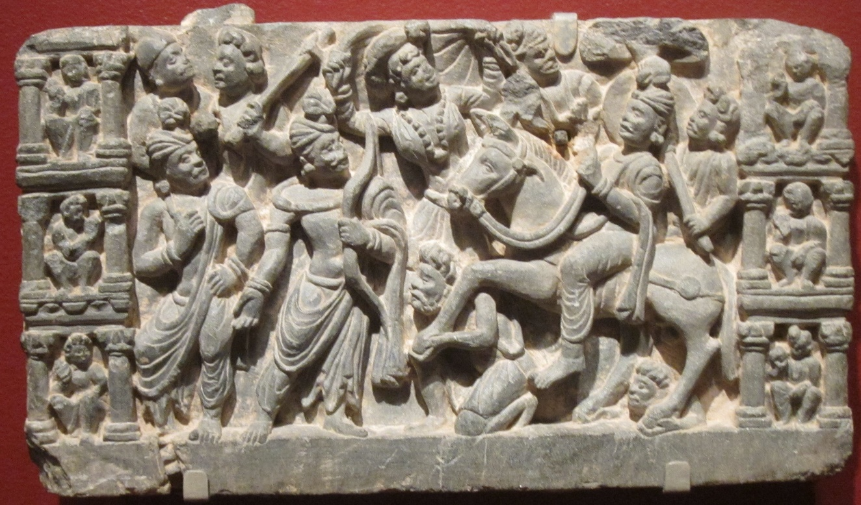

**Above**: **Prince Siddhartha leaves the Palace riding his horse amidst gathering of his family and friends:** Picture courtesy: Wikipedia: Source: Pakistan, Gandhara, schist, 2nd-3rd century, San Diego Museum of Art

**▲ Wanderings of Asetc Siddhartha**

In here we have gathered certain information from the scriptures, showing the activities of ascetic Siddhartha, the places he visited and people he met during the 6 years of his ascetic life. Earlier we have seen a statement made by the Blessed One saying that he spent 6 years of ascetic practice before giving it up and taking a new way to become a fully enlightened Buddha.

*“…iI performed a difficult and strenuous exercise for six years…”[[12]](#endnote-12)*

It was not possible to have a straight chain of events of this period from the scriptures, as there were many gaps. Hence, we took the liberty to fill some of the gaps from the ancient Buddhist texts and some other recognized sources. All of the references are duly mentioned in the end notes. Summary of events are given below:

**Age 29: Leaving Kapilavattu city** and home life on full moon day of Āsāḷha (Esala- month of April) to be an ascetic to discover a way out from all suffering.

**1) The day of departure**

\* According to Mahaparinibbana sutta (DN:16) the Buddha said*: I went forth seeking* ***what is good-*** *Twenty-nine years of age I was…”*

\* According to other sources:

1) year of 595 B.C. on a full moon day of Āsāḷha (Esala- month of April) he went forth…he went ridding on his horse ‘Kantaka’ with Channa (childhood friend) [[13]](#endnote-13)

2) Commentry to Samyutta Nikaya (Spk) identifies this **Channa** with the Bodhisatta’s charioteer who led him out of the palace on the night of his great renunciation. **See**: SN: Note:179, p. 11294. Bhikkhu Channa becoming an arahant is described in SN:22: 90 .

**2) Seven days from the day of departure**

\* According to other sources: the prince covering 30 yojanas, crossed the river Anoma, cut his hair, discarded his princely garments and dressed like an ascetic and spent 7 days at Anupiya Mango grove, enjoying his renunciation. [[14]](#endnote-14)

**3) Anupiya Mango Grove to Rajagaha city**

\* According to other sources: from Anupiya Mango grove the recluse Siddhartha walked 30 yojanas towards Magadha province and arrived at city of Rajagaha and stayed in a cave of Pandava Mountain outside the city. There he went round the city for alms and the King Bimbisara saw him and met him in the cave [[15]](#endnote-15)

**\* According to scriptures:** The bodhisatta arrived at Rajagaha and went for alms round in the city, then king Bimbisara saw him and was impressed with his good looks and serene manner followed him to the Pandava Mountain and paid respect, inquired about his clan and requested to live in the kingdom with him. As stated above in this section, Ascetic Siddhartha refused the offer [[16]](#endnote-16).

**4)** **From Rajagaha wandering in Magadha looking for teachers**

**\* According to scriptures:** First the bodisatta met Āḷāra Kālāma*,* a well-known teacher of Magadha and learned under him but relaised that teaching would not guide him to escape from suffering. Then he met another famous Magadhan teacher, **Uddaka Rāmaputta**, studied under him and came to know that teaching too would not guide him of what he is seeking and left him [[17]](#endnote-17)

**5)** **From the monastery of Uddaka Rāmaputta to Senani Village in Uruvela, Magadha**

**\* According to scriptures:** After leaving the hermitage of Uddaka, the bodhisatta wandering in stages arrived in beautiful forest grove in Uruvela and decided to settle down there near the river bank of Neranjaana. Then the five group of ascetics [[18]](#endnote-18) attended to bodhisatta [[19]](#endnote-19)

**6) Striving for enlightenment near the river bank of Neranjana in Uruvela forest (now called Bodh Gaya) from the age 29+ to 35**

**According to scriptures** this is the period the bodhisatta performed extreme ascetic practice and the five-group of ascetics lived with him hoping to see he gains the enlightenment [[20]](#endnote-20)

**▲ Finding a suitable place to strive**

This is what the Buddha to be said:

*“Still in search, bhikkhus, of what is wholesome, seeking the supreme state of sublime peace, I wandered by stages through the Magadhan country until eventually I arrived at Uruvelā, at Senānigama. There I saw an agreeable piece of ground, a delightful grove with a clear-flowing river with pleasant, smooth banks and nearby a village for alms resort. I considered: ‘This is an agreeable piece of ground; this is a delightful grove with a clear-flowing river with pleasant, smooth banks and nearby a village for alms resort. This will serve for the striving of a clansman intent on striving.’ And I sat down there thinking: ‘This will serve for striving’” [[21]](#endnote-21)*

**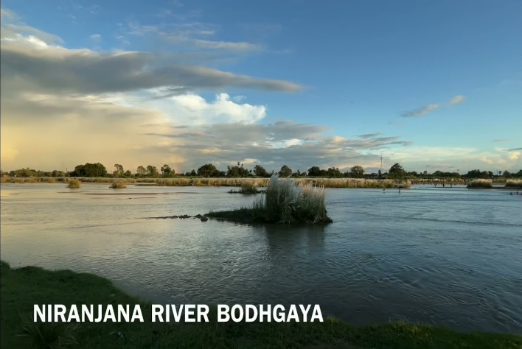**

**Present day picture of River Neranjana** at Bodh Gaya (Uruvela forest grove) picture courtesy:

You Tube.com

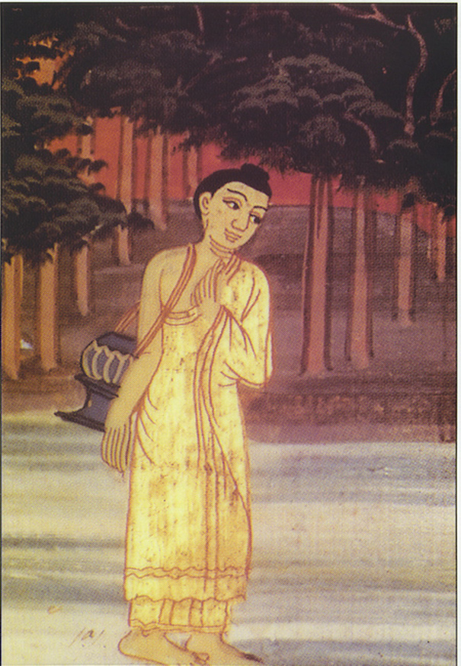**Acetic Siddhartha looking for a suitable place** **to meditate** -Picture Courtesy: http://nobleclass.weebly.com/buddhism-begins-in-india.html

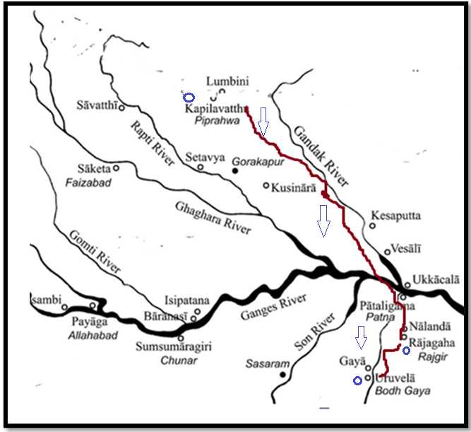

**Imagination of an Artist: Map showing the route of Ascetic Siddhartha ‘s wandering from Kapilavttu to Uruvela .** Distance: Kapilavatthu to Rajagaha about 518 km, Rajagaha -Uruvela about 71 km.

**Modern day road map** from Kapilavastu (Nepal) to Rajgir **(**by car10 hr 50 min (518.7 km) via NH 24)

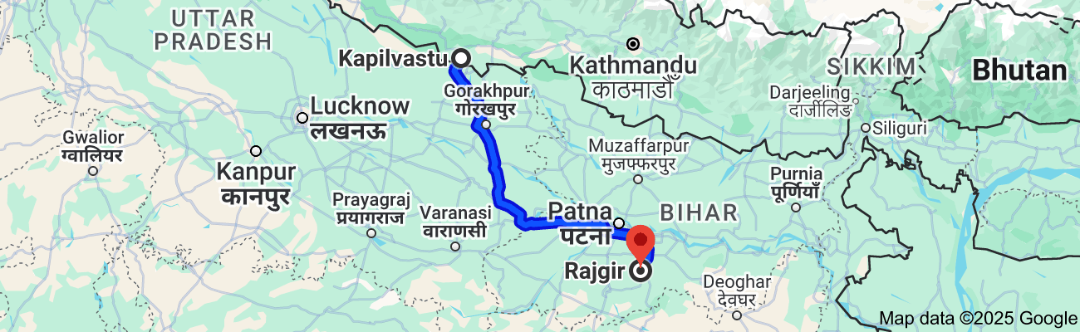

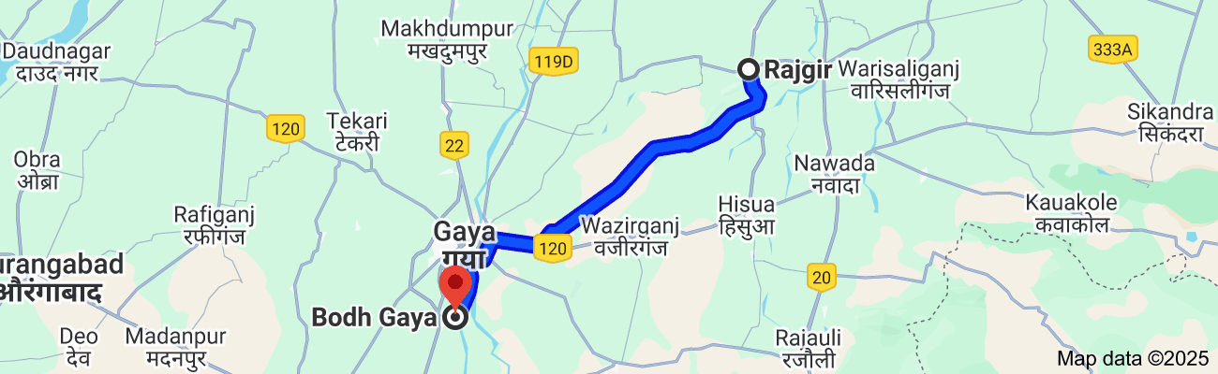**Map 2:** Modern day road map from Rajgir to Bodh Gaya (Uruvela). Distance **1 hr 50 min** (71.2 km) via Atari-Jethian-Tapovan-Banganga Rd and Bhindus - Chamandih Rd by car.

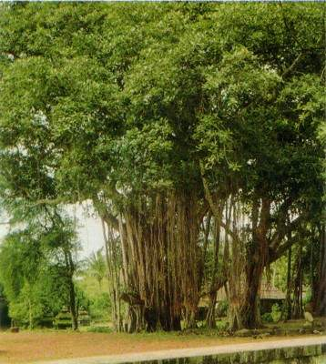

**Present day picture of Uruvela Forest Grove (Bodh Gaya) :** Picture courtesy nichiren-etudes.net

**▲Important Events in the life of Ascetic Siddhartha**

In here we would like to present some significant factors of ascetic life of the Buddha, which may would support our spiritual growth too!

**♦ Encounter with King Bimbisara of Magadha**

According Pabbaja sutta (Snp3.1)

“The Buddha (to be) went to Rājagaha- the Mountain fold of the Magadhans. He betook himself for alms, -replete with excellent marks- Bimbisāra saw him while standing atop his longhouse. Noticing that he was endowed with marks he said the following:

*‘Pay heed, sirs, to this one, - handsome, majestic, radiant;*

*accomplished in deportment, - he looks just a plough’s length in front.*

*Eyes downcast, mindful, - unlike one from a low family.*

*Let the king’s messengers run out, - and find where the mendicant will go.”*

Then the king went to the place where the ascetic Siddhartha was, greeted him graciously and said this:

*“You are just a youth – a lad in the prime of life.*

*You are endowed with beauty and stature, - Like an aristocrat of good birth.*

*In glory at the army’s head- surrounded by a troop of elephants.*

*I offer you pleasures – enjoy them! - But please tell me of your birth.”*

**Note**: Then the Ascetic Siddhartha refused the royal offer saying: *“****Seeing the danger in sensual pleasures, - Seeing renunciation as sanctuary, I shall go on to strive; - that is where my mind delights”****.* This is the first instance we see in the scriptures the reason for going forth. His determination not to go for royal pleasures again- indulge in sensual pleasures- is an important point for a monk or a nun who has gone forth to make a determination, not to abandon the practice for sensual pleasures. The Buddha here guides us that he was able to overcome sensual things for the sake of freedom- It seems like through his experience he is saying to us: As a human being I did it, so you could!

**♦ Ascetic Siddhartha’ s encounter with Teachers Āḷāra Kālāma and Uddaka Rāmaputta**

In Ariyapariyasena sutta (MN:26) the Buddha said to the monks the reasons for his visits to these two teachers:

*“Having gone forth, bhikkhus, in search of what is wholesome, seeking the supreme state of sublime peace, I went to Āḷāra Kālāma… (and also to**Uddaka Rāmaputta) … to lead the holy life in this Dhamma and Discipline”.[[22]](#endnote-22)*

**Note: \*** In his teaching the Buddha often mentioned that it is beneficial to lead a holy life under a good teacher and gave a criterion of how to identify a good teacher (see: MN: 95 (Cankī Sutta).

\* Here, the Buddha clearly pointed out that, if you are seeking the spiritual growth and if you do not get the proper guidance under the teacher whom you have selected, you should go out from there- that is what he did- when he was not satisfied with the teachings of the above teachers.

This is what he said about **Kalama’s teaching:**

*“ … but it occurred to me: ‘This Dhamma does not lead to …enlightenment, to Nibbāna, but only to reappearance in the base of neither-perception-nor-non-perception.’ Not being satisfied with that Dhamma, disappointed with it, I left…”* [[23]](#endnote-23)

\* **About Uddaka’s teaching:**

*‘This Dhamma does not lead to disenchantment, to dispassion, to cessation, to peace, to direct knowledge, to enlightenment, to Nibbāna, but only to reappearance in the base of neither-perception-nor-non-perception.’ Not being satisfied with that Dhamma, disappointed with it, I left”.*

**Note**: \* This show us that the bodhisatta clearly understood that one who attains the above states are is still not free from birth and death but is caught in the trap of Māra- see: MN: Note: 302, p.1093) \* The importance of this is for to understand is that going out of the path in order to attend other attainment are not conducive to a spiritual life. Later we can see how the Buddha pointed out the attainment of deep samadhi and Jahana is the right way to liberation.

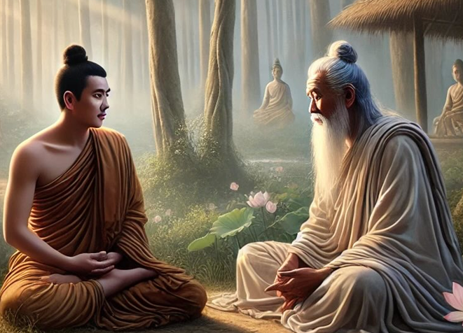

Ascetic Siddhartha learning under the teacher Āḷāra Kālāma

Picture Courtesy: https://elliottelford.com/alara-kalama/

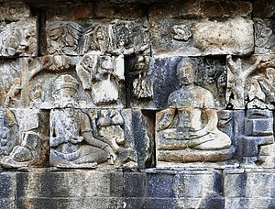

[Gautama Buddha](https://en.wikipedia.org/wiki/Gautama_Buddha) ( as an ascetic) meets the Uddaka Rāmaputta (left) in one of the bas-reliefs recounting the stages leading up to [awakening](https://en.wikipedia.org/wiki/Bodhi), [Lalitavistara](https://en.wikipedia.org/wiki/Lalitavistara_S%C5%ABtra" \l "The_Borobudur_reliefs" \o "Lalitavistara Sūtra), [Borobudur Temple Compounds](https://en.wikipedia.org/wiki/Borobudur_Temple_Compounds) 8th and 9th century, first corridor, main wall. Source: Wikipedia

**♦ Performing extreme austerities at the forest grove of Uruvela**

The Buddha retold his excessive ascetic practice during the time period of his wanderings thus:

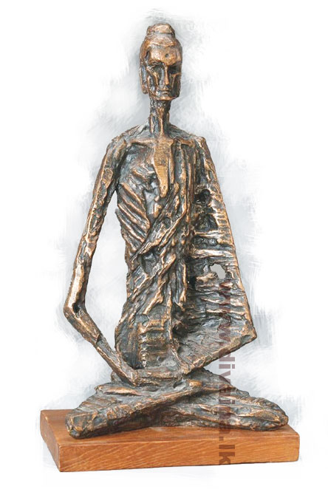*“I thought: ‘Suppose I practise the breathing-less meditation’…so I stopped the in-breaths and out-breaths through my mouth and nose. While I did so, there was a loud sound of winds coming out from my earholes. Just as there is a loud sound when a smith’s bellows are blown, so too, while I stopped the in-breaths and out-breaths through my nose and ears, there was a loud sound of winds coming out from my earholes. But although tireless energy was aroused in me and unremitting mindfulness was established, my body was overwrought and uncalm because I was exhausted by the painful striving…”*. [[24]](#endnote-24)

**Extreme ascetic practice of bodhisattva**: sculpture by Sri Lankan artist: Tissa Ranasinghe, picture courtesy Divaina.lk

“*Sāriputta, I recall having lived a holy life possessing four factors. I have been an ascetic—a supreme ascetic; I have been coarse—supremely coarse; I have been scrupulous—supremely scrupulous; I have been secluded—supremely secluded…* *“Such was* ***my asceticism,*** *Sāriputta, that I went naked, rejecting conventions, licking my hands, not coming when asked…* *such was* ***my coarseness****, Sāriputta, that just as the bole of a tindukā tree, accumulating over the years, cakes and flakes off, so too, dust and dirt, accumulating over the years, caked off my body and flaked off… Such was my coarseness, Sāriputta, that just as the bole of a tindukā tree, accumulating over the years, cakes and flakes off, so too, dust and dirt, accumulating over the years, caked off my body and flaked off…* *“Such was my* ***scrupulousness,*** *Sāriputta, that I was always mindful in stepping forwards and stepping backwards. I was full of pity even in regard to a drop of water thus: ‘Let me not hurt the tiny creatures in the crevices of the ground…* *“such was* ***my seclusion****, Sāriputta, that I would plunge into some forest and dwell there. And*

*when I saw a cowherd or a shepherd or someone gathering grass or sticks, or a woodsman, I would flee from grove to grove, from thicket to thicket, from hollow to hollow…”[[25]](#endnote-25)*

**Note:** Showing the extreme of the austerities that he has undergone before his enlightenment the Buddha sharing his experience with the world to show they are not the way for enlightenment. He said thus:

*“… but by this racking practice of austerities, I have not attained any superhuman states, any distinction in knowledge and vision worthy of the noble ones. Could there be another path to enlightenment?”[[26]](#endnote-26)*

Through his deep understanding and wisdom, we can see how he abandoned the extreme path and entered into the middle way: showing the importance of practice of deep meditation and attainment of jhānas:

*“I considered: ‘I recall that when my father the Sakyan was occupied, while I was sitting in the cool shade of a rose-apple tree, quite secluded from sensual pleasures, secluded from unwholesome states, I entered upon and abided in the first jhāna, which is accompanied by applied and sustained thought, with rapture and pleasure born of seclusion. Could that be the path to enlightenment?’ Then, following on that memory, came the realisation: ‘****That is indeed the path to enlightenment*** [[27]](#endnote-27)

Then the Buddha to be pointed out to us that pleasure of deep samadhi- Jhanas bring only wholesome and peace. This is important for mediator, as it shows that the pleasures-bliss come out from deep mediation should not be discard as it is part and partial of the practice. However, he has shown us even those statues also would be abandoned when through the 4th Jahana one gets in to the status of equanimity- the liberation:

“*With the abandoning of pleasure and pain…I entered upon and abided in the fourth jhāna…But such pleasant feeling that arose in me did not invade my mind and remain…“…I thought: ‘Why am I afraid of that pleasure that has nothing to do with sensual pleasures and unwholesome states?’ I thought: ‘I am not afraid of that pleasure since it has nothing to do with sensual pleasures and unwholesome states” [[28]](#endnote-28)*

**Note:**“This passage marks a change in the bodhisattva’s evaluation of pleasure; now he no longer regarded it as something to be feared and banished by the practice of austerities. Instead, what is born of seclusion and detachment is seen as a valuable accompaniment of to the higher stages along the path to enlightenment…” [[29]](#endnote-29)

**\*** Then the bodhisatta realizing that he needs physical strength to go in to such deep meditative attunements, commenced eating some food:

*“…and I ate some solid food—some boiled rice and porridge. Now at that time five bhikkhus were waiting upon me, thinking: ‘If our recluse Gotama achieves some higher state, he will inform us.’ But when I ate the boiled rice and porridge, the five bhikkhus were disgusted and left me, thinking: ‘The recluse Gotama now lives luxuriously; he has given up his striving and reverted to luxury.’* [[30]](#endnote-30)

**Note**: the five group were: Koṇḍañña, Bhaddiya, Vappa, Mahānāma, and Assaji. [[31]](#endnote-31).

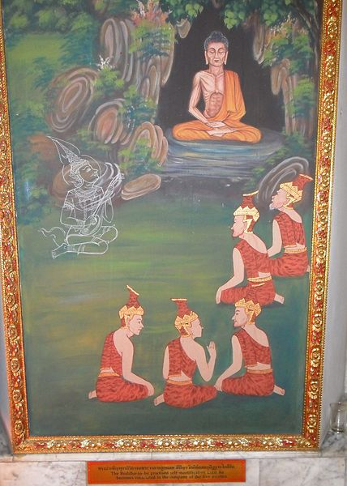

**Ascetic Siddhartha and his five attendants in Uruvela forest grove:** picture courtesy: Wikimedia Commons

We have seen the extreme austerities performed by the Buddha in his six years of ascetic life. Finally, through his wisdom he realized the folly of them abandoned and decided to open a new page in his life. Int the next section: 4 we can see how the Buddha achieved his enlightenment by following the ‘middle path’.

**◙ Summery**

\* In this section we saw prince Siddhartha leaving his home seeking ‘Truth’ or solution to ‘the Re-Births’ which brings endless sufferings.

\* At the meeting of powerful Maghadan king Bimbisara who offered him royal pleasures, but the bodhisattva had enough wisdom and determination to refuse it.

\* Meeting the two teachers: Āḷāra Kālāma and Uddaka Rāmaputta, famous in Magahda, he learned all about immaterial attainments but had the wisdom to realise though they are considered hither achievements to re-born in Brahma realms, when the time ends, one has to reborn again!

\* His realization of extreme ascetic practice, which was recognized as highest spiritual practice during that time was useless only harming the body and mind too. Later we can see that the first discourse of the Buddha instructed to avoid this way pf practice.

\* Though his supporters: five group left him, the Buddha to be never shaken on those mundane things and make a firm determination to attain to deep meditation- jhanas- the way to liberation.

**End Notes: Section 3**

1. For more vivid narration of this event see: Renunciation of the prince: The Great Chronicles of Buddhas by Venerable Mingun Sayadaw. [↑](#endnote-ref-1)
2. See: AN:3: 39.9. [↑](#endnote-ref-2)
3. See: MN: 26 (Ariyapariyesanā Sutta) [↑](#endnote-ref-3)
4. **See:** MN :36 (Mahāsaccaka Sutta) \* similar statement is given in MN :85 (Bodhirājakumāra Sutta). [↑](#endnote-ref-4)
5. At the time of the Parinibbāna of the Buddha, out of compassion for Subhadda, the Blessed One taught the Dhamma. Afterwards he sought ordination and the Buddha said to Venerable Ananda: ‘Let Subhadda go forth!’, and he became a monk and an Arahant. See: DN: Note:446, p.195. [↑](#endnote-ref-5)
6. DN: 16( Mahāparinibbāna Sutta 5.27 section The Great Passing). [↑](#endnote-ref-6)
7. Snp: 3.1 (Going Forth Sutta: Translated by Bhikkhu Sujato, www.suttacentral.net [↑](#endnote-ref-7)
8. This event is elaborated in: Four Omen of a recluse: The Great Chronicles of Buddhas by Venerable Mingun Sayadaw. [↑](#endnote-ref-8)
9. Source: Buddha-Vamsa-Pali & Chariya Pitaka Pali: 25 Gotama Buddha Vamsa: Vol.33. by Buddha Jayanti Tripitaka Series. [↑](#endnote-ref-9)
10. MN: 26 (Ariyapariyesena Sutta- The Noble Search) [↑](#endnote-ref-10)
11. This episode is mentioned in Section 2 of this compilation. [↑](#endnote-ref-11)
12. Source: Buddha-Vamsa-Pali & Chariya Pitaka Pali: 25 Gotama Buddha Vamsa: Vol.33. by Buddha Jayanti Tripitaka Series. [↑](#endnote-ref-12)
13. See: Renunciation of the prince: The Great Chronicles of Buddhas by Venerable Mingun Sayadaw. [↑](#endnote-ref-13)
14. **See**: Crossing the River Anoma: The Great Chronicles of Buddhas by Venerable Mingun Sayadaw. \* According to <http://gorakhpurandgautambuddha.blogspot.com/> Anoma river is now called River Ami in Siddharthnagar \* Ami is a tribute of Rapti river. [↑](#endnote-ref-14)
15. Ibid. [↑](#endnote-ref-15)
16. Snp:3.1 (Pabbaja Sutta) [↑](#endnote-ref-16)
17. MN: 26 (Ariyapariyesana sutta) [↑](#endnote-ref-17)
18. \* The five group later became the first 5 disciples of the Buddha are: Koṇḍañña, Bhaddiya, Vappa, Mahānāma, and Assaji also the first 5 arahants in Buddha’s dispensation. \* Ttradition says that ascetic Koṇḍañña from Kapilavatthu was the youngest of the eight persons summoned by King Suddhodana to the naming event of prince Siddhartha. He declared that the prince would definitely leave the lay life and attain enlightenment. He was keenly watching the progress of the prince and when the prince renounced and became an ascetic, he went with four of his friends: and also became ascetics living in the Deer Park of Isipathana and hearing that the bodhisatta reached Uruvela came their to look after him. [↑](#endnote-ref-18)
19. MN: 26 (Ariyapariyesana sutta), MN:36 (Maha Sachchaka sutta), MN:85 (Bodhirajakumara sutta). [↑](#endnote-ref-19)
20. Ibid. [↑](#endnote-ref-20)
21. MN:26. [↑](#endnote-ref-21)
22. Ibid. [↑](#endnote-ref-22)
23. See: MN:26. **Note:** The same description of the bodhisattva’s disappointment about the two teachers is also stated in MN: 36 (Mahāsaccaka sutta ) & MN:85 (Bodhirājakumāra sutta) [↑](#endnote-ref-23)
24. MN:36. [↑](#endnote-ref-24)
25. MN.12 (Mahā Sihanāda sutta). [↑](#endnote-ref-25)
26. MN:36. [↑](#endnote-ref-26)
27. MN:36. **Note**: During the Bodhisattha’s boyhood as a prince, on one occasion his father led a ceremonial ploughing at a traditional festival of the Sakyans. The prince was brought to the festival and a place was prepared for him under a rose-apple tree. When his attendants left him to watch the ploughing ceremony, the prince, finding himself all alone, spontaneously sat up in the meditation posture and attained the first jhāna through mindfulness of breathing. When the attendants returned and found the boy seated in meditation, they reported this to the king, who came and bowed down in veneration to his son (MN :Note: 389). [↑](#endnote-ref-27)
28. Mn:36. [↑](#endnote-ref-28)
29. Bhikkhu Bodhi’s observation, see: MN: Note:3909) [↑](#endnote-ref-29)
30. MN:36. [↑](#endnote-ref-30)
31. Ttradition says that ascetic Koṇḍañña from Kapilavatthu was the youngest of the eight persons summoned by King Suddhodana to the naming event of prince Siddhartha. He declared that the prince would definitely leave the lay life and attain enlightenment. He was keenly watching the progress of the prince and when the prince renounced and became an ascetic, he went with four of his friends: Bhaddiya, Vappa, Mahānāma, and Assaji and also became ascetics. [↑](#endnote-ref-31)